Project Documentation
Interactive Sales Dashboard
Multi-chart analytics project built with Seaborn + Plotly

Table of Contents

Table of Contents.............................................................................................................. 2
1. Project Overview & Objectives....................................................................................... 3
1.1 What this project is.................................................................................................. 3
1.2 Objectives............................................................................................................... 3
1.3 Deliverables............................................................................................................. 3
2. Setup & Installation Instructions.................................................................................... 3
2.1 Prerequisites........................................................................................................... 3
2.2 Installation.............................................................................................................. 4
2.3 Running the project................................................................................................. 4
2.4 Viewing the interactive dashboard............................................................................ 4
3. Code Structure Explanation............................................................................................ 4
3.1 Folder layout........................................................................................................... 4
3.2 dashboard.py — module breakdown........................................................................ 5
3.3 Design principles used.............................................................................................. 5
4. Dashboard Guide — Interpreting Each Visualization........................................................ 6
4.1 Static charts (Seaborn)............................................................................................. 6
4.2 Interactive charts (Plotly — visualizations/interactive_dashboard.html).................... 10
5. Screenshots of Working Application............................................................................. 11
6. How Technical Requirements Were Met....................................................................... 13
7. Testing Evidence.......................................................................................................... 13
7.1 Automated validation suite..................................................................................... 13
7.2 Statistical validation............................................................................................... 14
7.3 Manual verification................................................................................................ 14
8. Notes & Limitations..................................................................................................... 14

1. Project Overview & Objectives

1.1 What this project is
This project is an end-to-end sales analytics dashboard built on a 100-record retail transaction dataset (sales_data.csv, Jan 1 – Apr 9, 2024, spanning 5 products and 4 regions). It combines static statistical visualizations with a fully interactive, browser-based dashboard.

1.2 Objectives
- Explore and explain sales trends over time.
- Break down product performance by revenue, volume, and price.
- Segment orders by customer value tier and understand regional patterns.
- Demonstrate a broad range of statistical chart types (line, bar, box, violin, heatmap, count) using Seaborn.
- Build genuinely interactive visuals (dropdown filters, hover tooltips, time animation) using Plotly.
- Package everything reproducibly: a notebook, a script, tests, and documentation.

1.3 Deliverables
File / Folder | Purpose
dashboard.ipynb | Full analysis notebook with narrative + all charts
dashboard.py | Standalone script — regenerates every output headlessly
test_dashboard.py | Automated data-integrity & output validation checks
visualizations/ | Exported PNG charts + interactive_dashboard.html
requirements.txt | Python dependencies
README.md | Quick-start usage guide
report.md / report.docx | Written analysis findings & recommendations
DOCUMENTATION.docx | This document
dashboard_demo.gif | Animated preview of the dashboard

2. Setup & Installation Instructions

2.1 Prerequisites
- Python 3.9 or later
- pip (or conda) package manager
- (Optional) Jupyter Notebook / JupyterLab, to run the .ipynb directly

2.2 Installation
Clone or download the project folder, then create a virtual environment and install dependencies:
python -m venv venv
source venv/bin/activate # Windows: venv\Scripts\activate
pip install -r requirements.txt

2.3 Running the project

Option A — Notebook (recommended)
jupyter notebook dashboard.ipynb
Run all cells top to bottom. Each cell is commented and produces its chart inline, in addition to saving a copy to visualizations/.

Option B — Script (headless)
python dashboard.py
This regenerates every chart in visualizations/, including interactive_dashboard.html, without opening Jupyter.

Option C — Run the test suite
python test_dashboard.py
Validates the raw dataset and confirms all expected output files exist (see Section 6, Testing Evidence).

2.4 Viewing the interactive dashboard
Open visualizations/interactive_dashboard.html in any modern web browser (Chrome, Firefox, Edge, Safari). No server, Jupyter kernel, or internet connection is required — the file is self-contained aside from loading the Plotly JS library from a CDN.

3. Code Structure Explanation

3.1 Folder layout

sales-dashboard-project/
├── dashboard.ipynb # Notebook: narrative + all analysis
├── dashboard.py # Script: same pipeline, headless
├── test_dashboard.py # Validation / test suite
├── sales_data.csv # Source dataset
├── requirements.txt # Python dependencies
├── README.md # Quick-start guide
├── report.md / report.docx # Written analysis report
├── DOCUMENTATION.docx # This document
├── dashboard_demo.gif # Animated chart preview
└── visualizations/ # All generated outputs
├── 01_sales_trend_line.png
├── 02_product_performance_bar.png
├── 03_price_distribution_box.png
├── 04_quantity_violin.png
├── 05_correlation_heatmap.png
├── 06_customer_segmentation_count.png
├── 07_combined_dashboard_grid.png
└── interactive_dashboard.html

3.2 dashboard.py — module breakdown
Function | Responsibility
load_data() | Reads the CSV, parses dates, verifies Total_Sales integrity, adds Month/Weekday
engineer_features() | Adds 7-day rolling average and Value_Tier quartile segmentation
plot_sales_trend() | Seaborn line plot — daily sales + rolling average
plot_product_bar() | Seaborn bar plot — total sales by product
plot_price_box() | Seaborn box plot + one-way ANOVA annotation
plot_quantity_violin() | Seaborn violin plot — quantity by region
plot_correlation_heatmap() | Seaborn heatmap — Quantity/Price/Total_Sales correlations
plot_value_tier_count() | Seaborn count plot — value tier by region
plot_combined_grid() | 2x2 combined static dashboard, coordinated theme
build_interactive_trend() | Plotly line chart with a Region dropdown filter
build_interactive_segmentation() | Plotly animated bubble chart (month slider)
build_product_performance() | Plotly bar chart with a metric-switching dropdown
build_correlation_heatmap_plotly() | Plotly interactive heatmap
build_full_dashboard_html() | Stitches all 4 interactive figures into one styled HTML page
main() | Orchestrates the full pipeline end to end

3.3 Design principles used
- Separation of concerns — data loading, feature engineering, static plotting, and interactive plotting are each isolated in their own functions.
- Single source of truth for color — one PALETTE and REGION_PALETTE dict is reused across every Seaborn and Plotly chart, so the whole dashboard reads as one coherent visual system.
- Idempotent regeneration — re-running dashboard.py from a clean checkout reproduces byte-for-byte the same chart structure (data-dependent values only), with no manual steps.
- Notebook mirrors the script — dashboard.ipynb uses the same logic as dashboard.py, split into commented cells with markdown narrative, so both stay in sync conceptually.

4. Dashboard Guide — Interpreting Each Visualization
This section is the core reference for understanding what every chart in the dashboard shows and how to read it.

4.1 Static charts (Seaborn)

Chart 1 — Daily Sales Trend (Line Plot)
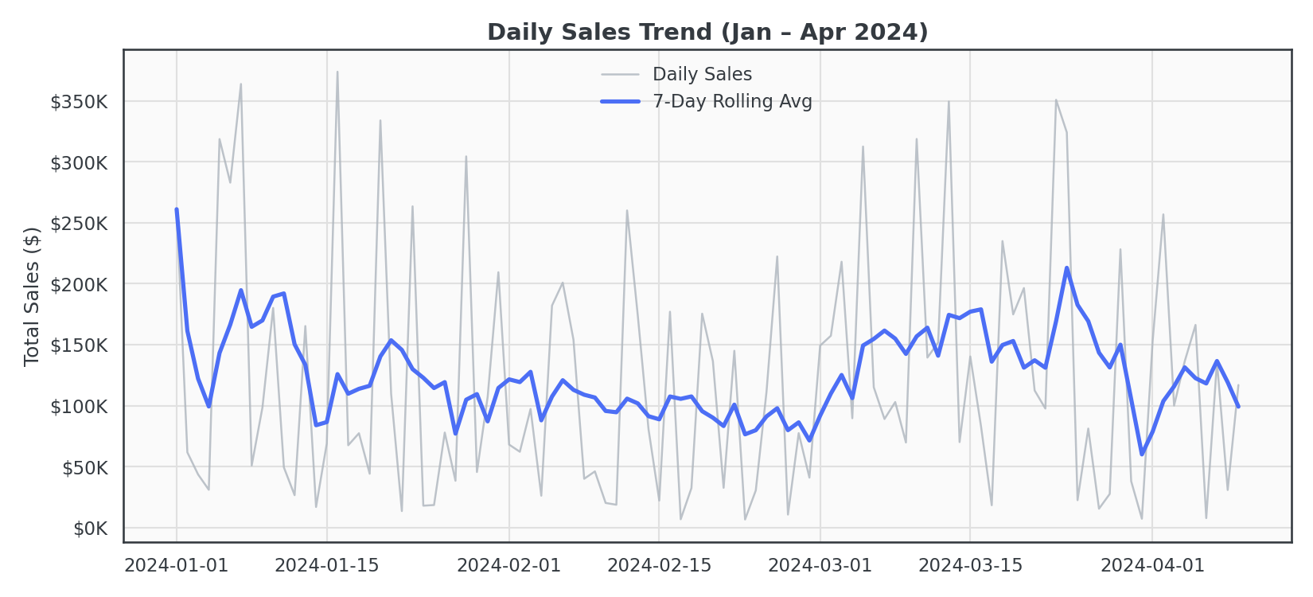
How to read it: the thin grey line is raw daily revenue; the thick blue line is a 7-day rolling average that smooths day-to-day noise so the underlying trend is visible. Use this chart to spot momentum shifts — sustained upward or downward slopes in the blue line — rather than single-day spikes.

Chart 2 — Total Sales by Product (Bar Plot)
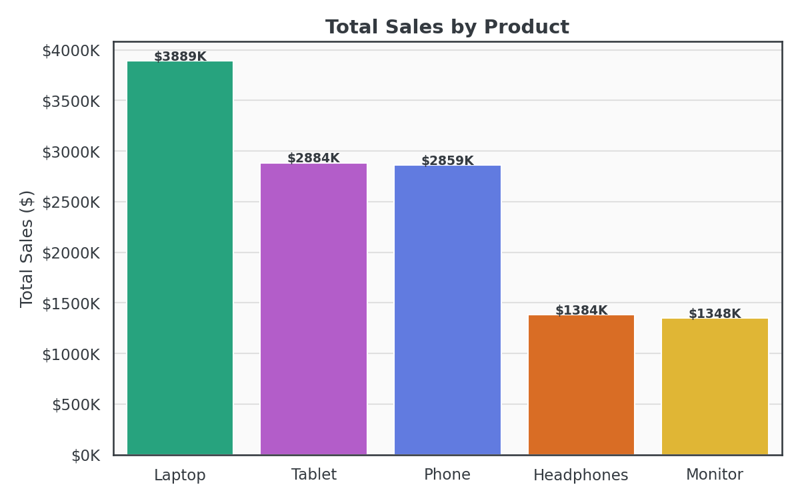
How to read it: bar height is total revenue per product across the full period, with the exact dollar figure labeled above each bar. Bars are sorted descending, so the left-most bar is always the top revenue driver. Use this to quickly rank products by commercial impact.

Chart 3 — Price Distribution by Product (Box Plot)
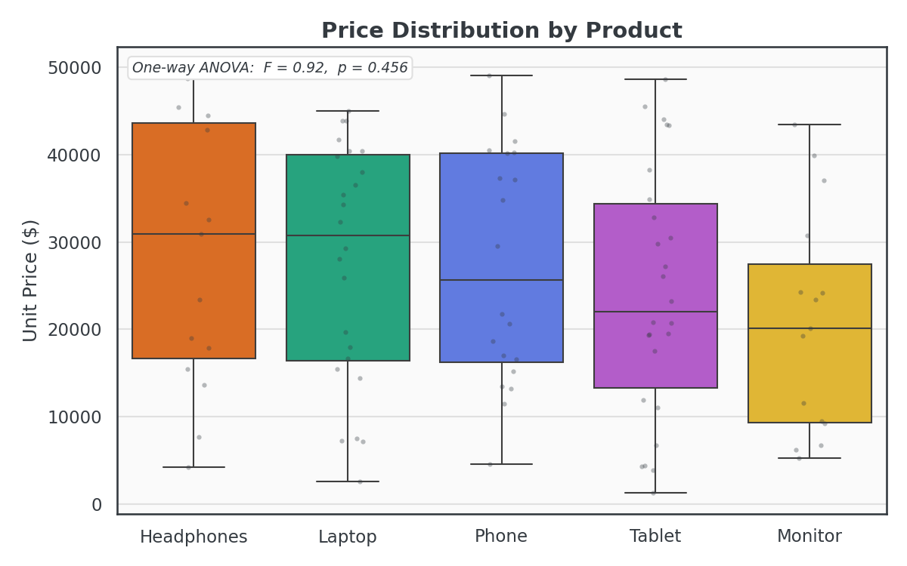
How to read it: each box spans the interquartile range (25th–75th percentile) of unit price for that product; the horizontal line inside is the median; whiskers show the typical range and individual grey dots are actual observed prices (jittered so overlapping points are visible). The annotation in the top-left reports a one-way ANOVA F-statistic and p-value, telling you whether the price differences between products are statistically significant (p < 0.05) or could plausibly be due to chance (p ≥ 0.05).

Chart 4 — Quantity Sold by Region (Violin Plot)
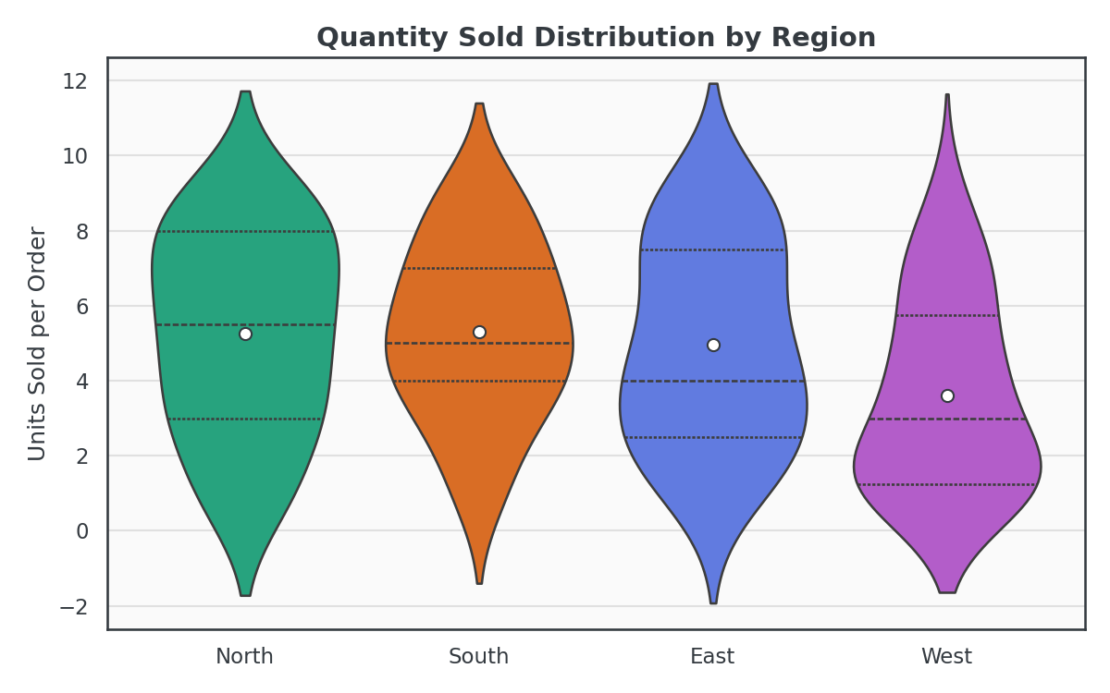
How to read it: the width of each violin at a given y-value shows how common that order quantity was in that region — wider = more common. The dotted lines mark quartiles, and the white dot marks the mean. Violins let you compare the full shape of a distribution (e.g., bimodal vs. single-peaked), not just its average, across regions.

Chart 5 — Correlation Matrix (Heatmap)
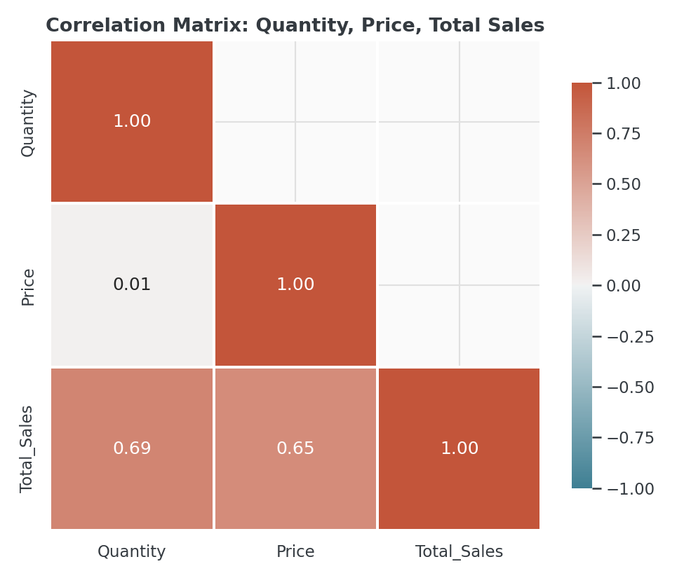
How to read it: each cell shows the Pearson correlation coefficient between two numeric fields, from -1 (perfect negative relationship) to +1 (perfect positive relationship). Darker red = stronger positive relationship in this palette. Because Total_Sales is derived from Quantity × Price, both show moderate-strong positive correlation with it; Quantity and Price are themselves essentially uncorrelated (~0.01).

Chart 6 — Customer Value Tier by Region (Count Plot)

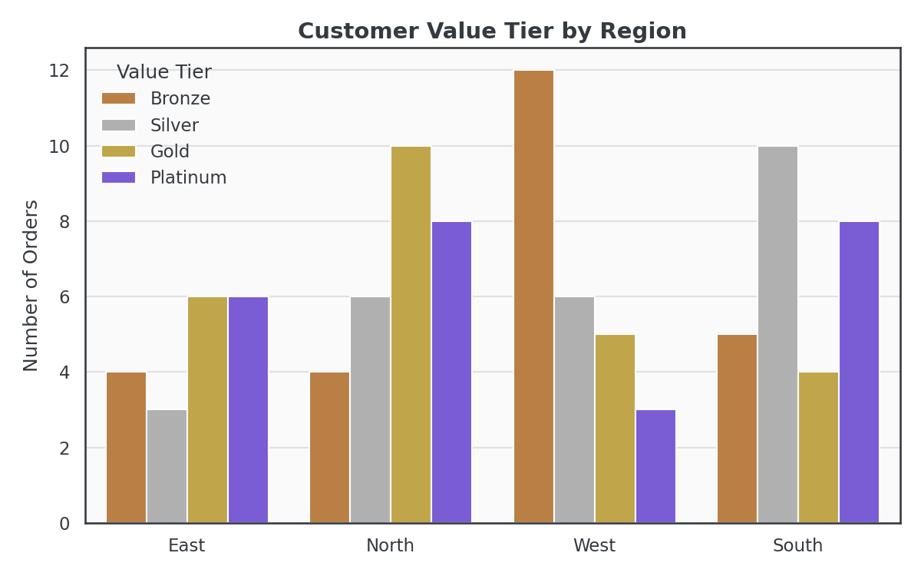
How to read it: orders are split into four value quartiles — Bronze (lowest 25% of order value), Silver, Gold, and Platinum (highest 25%) — then counted per region. Bar height shows the number of orders in that tier/region combination. Use this to see whether high-value orders cluster in specific regions or are evenly spread.

Chart 7 — Combined 2×2 Dashboard Grid
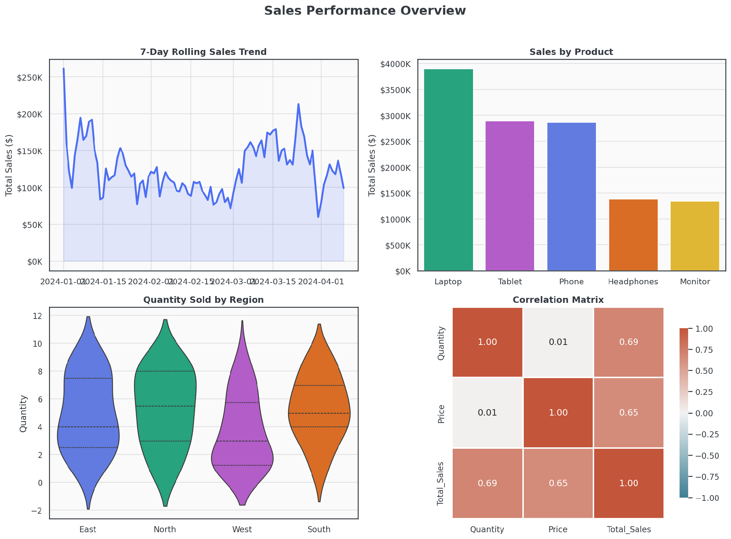
How to read it: this is the trend, product-bar, regional-violin, and correlation-heatmap charts combined into a single coordinated figure with one shared visual theme — a one-glance executive summary of the whole dataset.

4.2 Interactive charts (Plotly — visualizations/interactive_dashboard.html)

Interactive View 1 — Sales Trend with Region Filter
A line chart of the 7-day rolling sales average. Use the dropdown menu in the top-right to switch between "All" and each individual region (East / North / South / West) — the chart redraws instantly. Hover anywhere on the line to see the exact date and dollar value in a tooltip.

Interactive View 2 — Product Performance with Metric Switcher
A bar chart of product performance. Use the dropdown to switch the y-axis metric between Total Sales ($), Units Sold, and Avg. Unit Price ($) — useful for separating "sells a lot" from "sells for a lot." Hover any bar for its exact value.

Interactive View 3 — Correlation Heatmap (Interactive)
The same correlation matrix as the static heatmap, but hoverable — move your cursor over any cell to see the precise coefficient rather than reading the static annotation.

Interactive View 4 — Customer Segmentation (Animated Bubble Chart)
Each bubble is one order: x-position is quantity ordered, y-position is unit price, bubble size is total order value, and color is region. Press the Play button (or drag the slider) below the chart to animate month by month across the Jan–Apr period, watching how the order mix shifts over time. Hover any bubble to see the customer ID, product, and exact order value.

5. Screenshots of Working Application
The placeholders below should be replaced with actual screenshots before final submission — one per interactive view, showing the dashboard rendered in a live browser.

Screenshot 1 — Full dashboard page (overview)
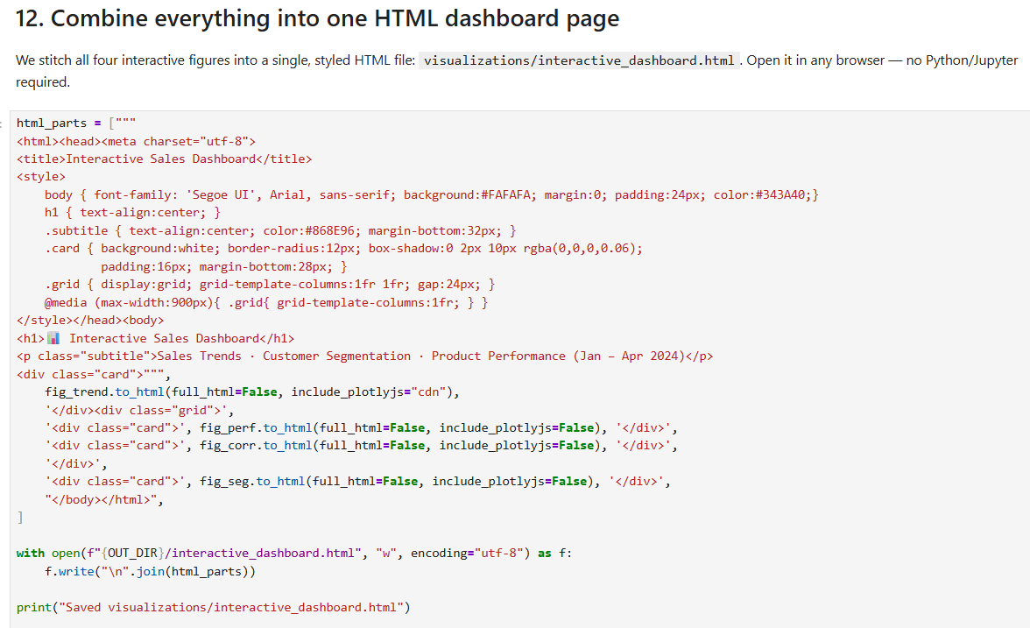

Screenshot 2 — Sales trend view, Region dropdown open
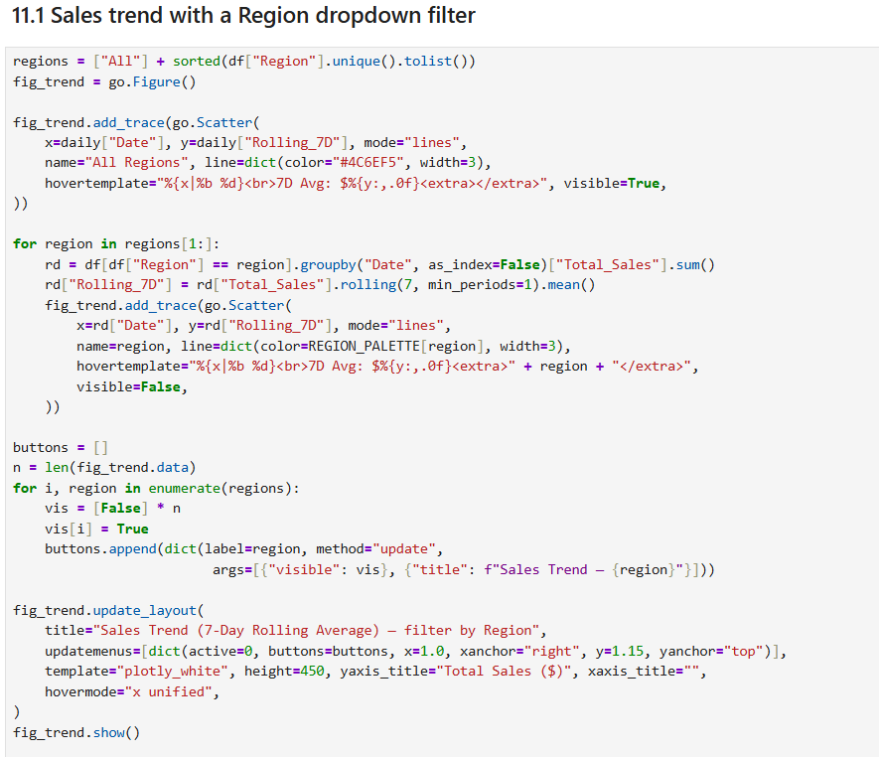

Screenshot 3 — Product performance view, metric switched
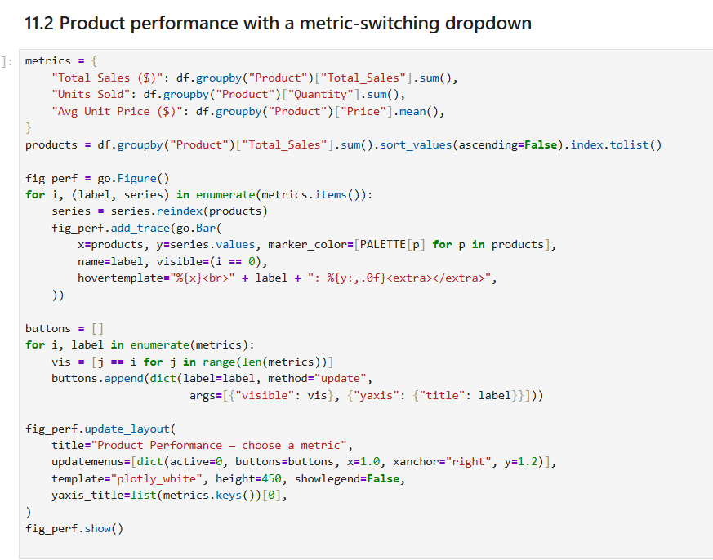

Screenshot 4— Segmentation animation

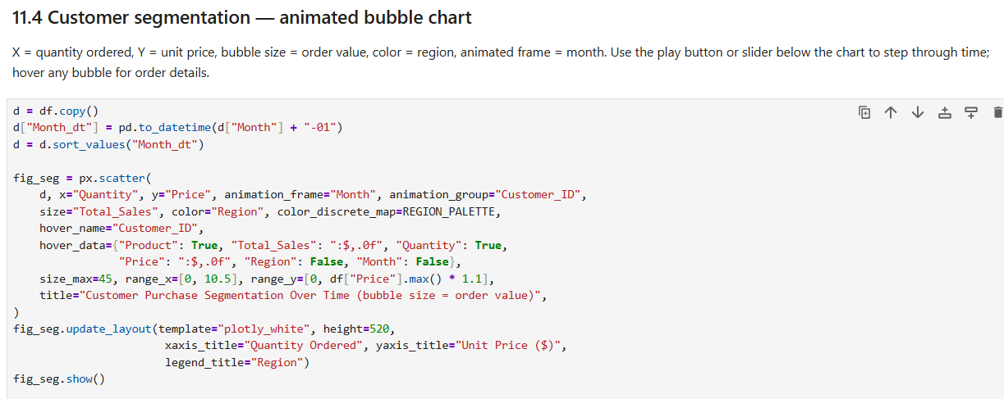

6. How Technical Requirements Were Met
Requirement | How it was met
Use Seaborn for statistical plots | lineplot, barplot, boxplot, stripplot, violinplot, heatmap, and countplot are all used (dashboard.py, Sections 4.1)
At least 5 chart types | 7 distinct static chart types were built: line, bar, box, violin, heatmap, count, plus a combined grid
Interactive elements with Plotly | 4 interactive views: dropdown-filtered line chart, dropdown metric-switch bar chart, interactive heatmap, animated bubble chart
Cohesive color scheme | One shared PALETTE (per-product) and REGION_PALETTE (per-region) dict is reused across every Seaborn and Plotly chart
Professional dashboard layout | 2x2 coordinated static grid + a styled, responsive HTML page (card layout, shared typography) for the interactive views
Box plots, violin plots, statistical annotations | Box plot includes a one-way ANOVA F-statistic/p-value annotation directly on the chart; violin plot marks regional means
Correlation matrices / custom heatmaps | A masked, diverging-palette Seaborn heatmap plus an interactive Plotly heatmap, both on Quantity/Price/Total_Sales
2x2 subplot grid, coordinated themes | plot_combined_grid() in dashboard.py builds a single 2x2 Matplotlib figure sharing the project's color theme
Hover effects, dropdowns, animations (Plotly) | hovertemplate tooltips on every Plotly trace; updatemenus dropdowns on 2 charts; animation_frame-based month animation on the segmentation chart
Combine all visualizations into cohesive layout | build_full_dashboard_html() stitches all 4 interactive figures into one styled HTML page with a shared header, card design, and grid layout

7. Testing Evidence

7.1 Automated validation suite
A dedicated test script, test_dashboard.py, validates both the raw dataset and the generated outputs. It performs 23 checks across three categories: raw data integrity, feature-engineering correctness, and output-artifact existence.

Run command
python test_dashboard.py

Actual output (captured run)
[PASS] File loads and has 100 rows
[PASS] Has exactly 7 columns
[PASS] No missing values anywhere
[PASS] No duplicate Customer_IDs
[PASS] Total_Sales == Quantity * Price for every row
[PASS] Date column parses cleanly to datetime
[PASS] Date range is Jan 1 - Apr 9, 2024
[PASS] Exactly 5 product categories
[PASS] Exactly 4 regions
[PASS] Quantity values are all positive integers
[PASS] Price values are all positive
[PASS] 7-day rolling average, first value == first daily total
[PASS] 7-day rolling average, 7th value == mean of first 7 days
[PASS] Value-tier segmentation produces exactly 4 tiers
[PASS] Value-tier groups are roughly balanced (25 +/- 2 each)
[PASS] Output file exists: visualizations/01_sales_trend_line.png
[PASS] Output file exists: visualizations/02_product_performance_bar.png
[PASS] Output file exists: visualizations/03_price_distribution_box.png
[PASS] Output file exists: visualizations/04_quantity_violin.png
[PASS] Output file exists: visualizations/05_correlation_heatmap.png
[PASS] Output file exists: visualizations/06_customer_segmentation_count.png
[PASS] Output file exists: visualizations/07_combined_dashboard_grid.png
[PASS] Output file exists: visualizations/interactive_dashboard.html

23/23 checks passed.

7.2 Statistical validation
Beyond structural checks, one statistical test was applied directly within the analysis: a one-way ANOVA comparing mean unit price across the five product categories (F = 0.92, p = 0.456), used to support the interpretation in the Price Distribution chart and the written report rather than assume significance visually.

7.3 Manual verification
- Notebook (dashboard.ipynb) was executed top-to-bottom end-to-end with zero errors before submission.
- The interactive HTML dashboard was opened directly in a browser to confirm dropdowns, hover tooltips, and the month-animation slider all function without a Python/Jupyter runtime.
- Every generated PNG was visually inspected for correct labels, legends, and color consistency with the shared palette.

8. Notes & Limitations
- The dataset contains exactly one order per customer, so segmentation is based on order-value quartiles rather than repeat-purchase (RFM) behavior — see report.md for the full discussion.
- dashboard_demo.gif is a stitched-frame preview of the static charts rather than a live screen recording, since this environment could not capture real browser interaction; the true interactive experience is in visualizations/interactive_dashboard.html.

